1 Write an HTML document (calculator.html) whose sole function is to load and execute a JavaScript file calculator.js. The JavaScript code repeatedly prompts for 2 numbers (x and y) and for an arithmetic operator (addition (+), subtraction (-), modulus (%), division (/), and multiplication (\*)) as shown in the three dialog boxes below.

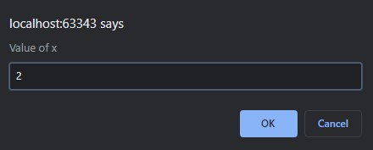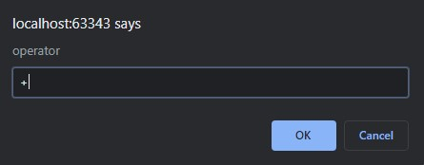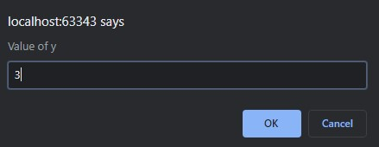

Then the page asks the user to continue the loop as shown below. The user exits the loop by clicking the cancel button. If the user clicks OK, then the page will show three prompts again to get more user input

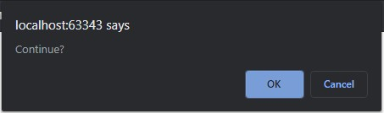

The program constructs a table in which shows numbers, an operator, and a computation result as a row. If an operator is not one of (+,-,\*,/,%), then the table show an error message in the result column. If the user puts non-numeric characters for x and y (you can check it by *isNaN(…)*), then the table shows another error message in the result column . The image below shows the examples of the table:

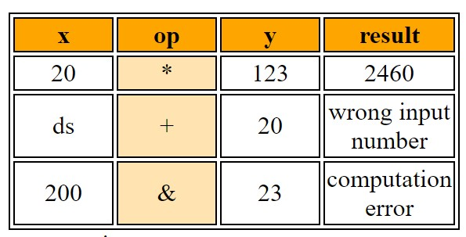

The simplest way to create a table with JavaScript is

*document.write("<table>");*

*document.write("<tr><th>header1</*th>…. <th>headerN</th>*</tr>"); document.write("<tr><td>column1</*td>…. <td>columnN</td>*</tr>"); document.write("</table>");*

Define your own table style. You can find how to style an HTML table here:

<https://www.w3schools.com/css/css_table.asp>

After exiting the loop, the program constructs another table in which shows a minimum, maximum, average, and total of the results as a row. For this table, do not use any results that have an error. The below images are examples:

